H.T No
Regulations:
A15

Sreenidhi Institute of Science and Technology
(An Autonomous Institution)
Code No: 5C303 Date: 12-Sept-2024 (FN)

B.Tech II-Year I- Semester External Examination, Sept - 2024 (Supplementary)
Probability Theory and Stochastic Process (ECE)

Time: 3 Hours Max.Marks:75

Note: a) No additional answer sheets will be provided.
b) All sub-parts of a question must be answered at one place only, otherwise it will not be valued.
c) Missing data can be assumed suitably.

Bloom's Cognitive Levels of Learning (BCLL)

Remember | L1 | Apply | L3 | Evaluate | L5
Understand | L2 | Analyze | L4 | Create | L6

Part - A Max.Marks:25
Answer all QUESTIONS

 |  | BCLL | CO(s) | Marks
1 | Consider a telegraph source generating two symbols: dot and dash. The dots were twice as likely to occur as dashes. Find the probabilities of the dots occurring and dash’s occurring? | L1 | CO1 | [2M]
2 | Write any three properties of the Gaussian random variable. | L2 | CO2 | [2M]
3 | State Central Limit Theorem for i) unequal and ii) equal distributions | L3 | CO3 | [2M]
4 | Determine the mean of the process 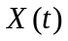, for which the autocorrelation function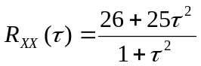 | L3 | CO4 | [2M]
5 | Define mean ergodic process. | L3 | CO5 | [2M]
6 | Write the relation between Power spectrum and Auto correlation. | L2 | CO6 | [3M]
7 | What are the conditions to be satisfied by a function to qualify as a Random Variable? | L1 | CO2 | [3M]
8 | Define uncorrelated random variables. | L1 | CO4 | [3M]
9 | Define thermal noise. | L1 | CO6 | [3M]
10 | Define moments of a random variable. | L2 | CO2 | [3M]
Part – B Max.Marks:50
ANSWER ANY FIVE QUESTIONS. EACH QUESTION CARRIES 10 MARKS.

 |  |  | BCLL | CO(s) | Marks
11. | a) | Two boxes B1 and B2 contain 100 and 200 transistors respectively. Box B1 has 15 defective transistors and B2 has 10 defective transistors. Suppose one box is selected at random and one transistor is picked at random. What is the probability that it is defective? | L3 | CO1 | [5M]
 | b) | State and explain the laws of probability. | L4 | CO1 | [5M]
12. | a) | For the Uniform random variable with density function 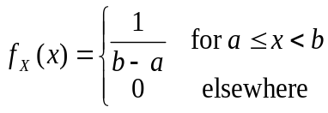  find (i) 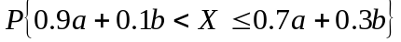 (ii) 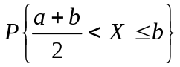 | L5 | CO2 | [5M]
 | b) | For a Gaussian random variable  having 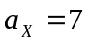and 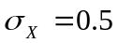 compute the probabilities of the events (i) 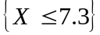 (ii)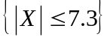 | L3 | CO2 | [5M]
13. | a) | The Joint probability density function of two random variables X and Y is  f_{xy}(x,y) = C(2X+Y) 0 ≤ X ≤ 1, 0 ≤ Y ≤ 2  Find (i) the value of ‘C’ (ii) marginal distribution functions of X and Y | L2 | CO3 | [5M]
 | b) | If X and Y are two independent random variables and Z = X+Y, relate their mean values m_{X}, m_{Y} and m_{Z}. | L3 | CO3 | [5M]
14. | a) | Explain Autocorrelation function of a random process. | L3 | CO4 | [5M]
 | b) | Given the autocorrelation function, for a stationary ergodic process with no periodic components, is 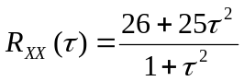. Determine the mean and variance of the process | L4 | CO4 | [5M]
15. | a) | A random process is given as X(t) = At, Where ‘A’ is uniformly distributed random variable in the interval (0, 4). Find whether X(t) is wide sense stationary or not? | L3 | CO5 | [5M]
 | b) | For a stationary ergodic process having the autocorrelation function shown in below fig.  Find (i)E[X(t)] (ii) E[X²(t)] (iii) σ_{x}²  R_{xx}(τ)  50  20  -10 0 10 τ | L2 | CO5 | [5M]
16. | a) | Derive the relation between input PSD and output PSD of an LTI system | L2 | CO6 | [5M]
 | b) | If 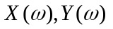 and 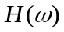are the respective Fourier transforms of input signal 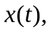 response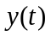 and network’s impulse response 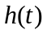, show that 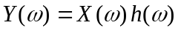 | L3 | CO6 | [5M]
17. | a) | Consider the experiment of tossing a coin three times. What is the probability that heads appear at the first two tosses. | L3 | CO1 | [5M]
 | b) | Let Y=X². Find f_{Y}(y) if X is N(0,1). | L5 | CO2 | [5M]
18. | a) | Explain cross correlation of two random processes. | L2 | CO4 | [5M]
 | b) | Calculate the equivalent noise bandwidth of an RC Low pass filter. How it is related to its 3 db Bandwidth. | L3 | CO5 | [5M]

-- 00 -- 00 –

